BALLYBRITTAS PORTAL TOMB
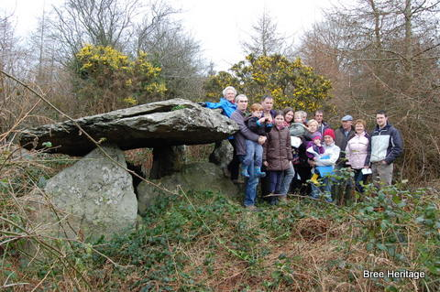
The dolmen at Ballybrittas dates from Neolithic period (4000-2500 BC) and is probably Wexford’s oldest standing structure. It is located on the lower slopes of Bree Hill and this affords it clear views of the surrounding farmland, which is well drained and fertile. The tomb consists of two large portal stones and a backstone that support a substantial roofstone. In addition the dolmen has two side stones and a sill stone, the latter being located at the tombs east-facing entrance. Together these elements enclose a small rectangular chamber in which the burial remains would have been placed. This form of burial monument is known as a portal tomb. A second, now collapsed, portal tomb is also recorded roughly 8 miles to the south of Ballybrittas at Newbawn, Adamstown.
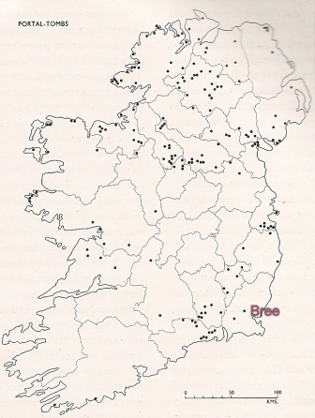Portal tomb distribution map (Waddle 1998, p. 89, fig. 41)
The majority of the 174 or so portal tombs that are found in the country are located in the northern half of the island, although there are outliers in the southeast, especially around Waterford (see map across). The tombs generally consist of two large portal stones defining the entrance and backstone, all of which support the roofstone. The roofstone can be of considerable size, with the largest example at Brownshill, Co. Carlow weighing circa. 100 tonnes. It is not know how these very large stones were moved and raised but it probably involved a combination of wooden rollers, ropes and man/animal power. It is possible that ramps of earth or stone were used to haul the large roof stones into place and some portal tombs have evidence for denuded cairns, which may have been used for this purpose.
Very few Irish portal tombs have been excavated but those that have include the iconic Poulnabrone Dolmen from the Burren, Co. Clare. The excavation of the interior of this monument uncovered the remains of 21 people, 16 adults and 5 children. The bones were disarticulated and had obviously been deposited in the tomb in a defleshed condition. This suggested a complex burial ritual where the bodies had been firstly stored or buried elsewhere until they had decomposed. The bare bones were then transferred to the portal tomb for final interment.
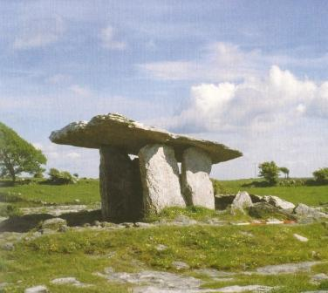Pounabrone tomb (Jones 2004, p.31,fig. 3; after A. Gilmer)
The skeletal remains from Poulnabrone give an insight into the lives our early ancestors. They appear to have experienced relatively short lives with only one person being older than 40. They also worked hard and were used to carrying heavy loads as evidenced by the arthritic condition of many neck and shoulder bones. Analysis of the children’s teeth revealed that they suffered from periods of either malnutrition or infections, especially between the ages of 3 and 6. Evidence for violence was also encountered amongst the burial remains. A depressed fracture, possibly caused by a stone projectile was identified on one of the skulls, while a broken rib bone may have been caused by an aggressive blow. Even more startling a fragment of a flint projectile point, probably an arrowhead, was found embedded in a hip bone. There was no trace of infection or healing so the wound had occurred around the time of death.
Radiocarbon analysis indicates that the Poulnabrone portal tomb was in use between 3800-3200 BC and a similar date range may be suggested for the Ballybrittas monument. It is not hard to imagine, 5,000 years ago, Bree’s first farming communities gathering together to place the remains of their ancestors in the portal tomb at Ballybrittas. The fact that it is still standing shows its significance, not just to the people who constructed it, but also to proceeding generations of Bree people.
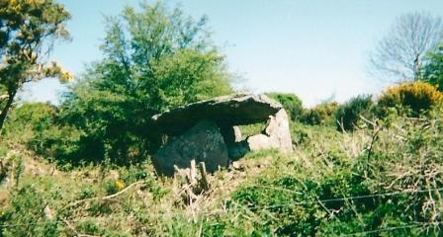Ballybrittas Portal Tomb in the late 1990s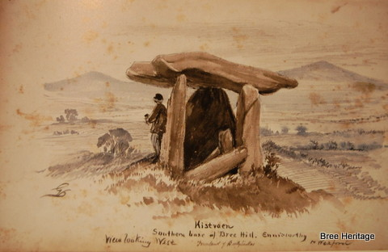Sketch of Ballybrittas dolmen by G. V. de Noyer c. 18

